

**APARTMENT**

**MANAGEMENT**

**SYSTEM**

**A PROJECT REPORT**

***Submitted by***

**RAMPRABU P-21BIT036**

**RUPAK G B- 21BIT039**

***in partial fulfilment for the award of the***

***degree of***

BACHELOR OF TECHNOLOGY

**in**

INFORMATION TECHNOLOGY **KUMARAGURU**

**COLLEGE OF TECHNOLOGY COIMBATORE**

**(An autonomous institution affiliated to Anna University, Chennai)**

I

**BONAFIDE CERTIFICATE**

Certified that this project report “**APARTMENT MANAGEMENT SYSTEM**” is the bonafide work of ***RAMPRABU P(21BIT036) and RUPAK G B (21BIT039)*** who carried out the project work under my supervision.

SIGNATURE SIGNATURE

**Dr. M. ALAMELU Dr. P.SHENBAGAM**

**HEAD OF THE DEPARTMENT SUPERVISOR**

Professor Assistant Professor

Information Technology Information Technology

**TABLE OF CONTENTS PAGE NO.**

**DECLARATION 4**

**ABSTRACT 5**

**SYSTEM STUDY 6**

**EXISTING SYSTEM 6**

**PROPOSED SYSTEM 7**

**SYSTEM DESIGN 8**

**ER DIAGRAM 8**

**TABLE DESIGN 9**

**TABLE CREATION AND QUERIES 10**

**INTEGRATION OF FRONT END 14**

**SCREENSHOTS 41**

**CONCLUSION 50**

**REFERENCES 51**

# DECLARATION

We ***RAMPRABU P(21BIT036) and RUPAK G B (21BIT039)*,**

hereby declare that the project “**APARTMENT MANAGEMENT SYSTEM**” is done by us and to the study of our knowledge, a similar work has not been submitted to any other institution, for the fulfilment of the required course of study. This report is submitted on the partial fulfilment of the requirements for all awards of the Degree of Bachelor of Information Technology at Kumaraguru College of Technology, Coimbatore. We certify that the declaration made above by the candidates is true.

|  |  |
| --- | --- |
| Place: Coimbatore | **Dr. P. SHENBAGAM**  Assistant Professor |
| Date: | Information Technology |

# ABSTRACT

Our Apartment Management System aims at providing a database system for the residents of the apartment and for the people who are looking for apartment and also for the managing team of the apartment.

The prime objective is to create table for storing the details about blocks, their floors and the apartments in each block and also the people who resides in that apartment.

Our project also includes features like subscriptions for recreations, water and electricity bills, visiting log and parking lot.

The project also contains features to delete the residents and if the owner is deleted then the ownership will be handled well by passing it to senior citizen of the resident.

The visiting log is maintained by keeping track of the current date and time while checking in and out. The subscription log will be added by the admin based on their usage. Then the system will be kept track of the mode of payment the reference id if online payment and the paid date.

# SYSTEM STUDY

# EXISITING SYSTEM:

The current system is a manual based which is not computerized especially for the residents of the apartment. Also this system takes a lot of time for performing different activities and difficult to maintain the visitors’ records.

Limitations of Existing System:

* Existing System is completely hard-copy.
* Time consuming procedure.
* Tracking of records is difficult.

On a whole, every year the company is designing new apartments and its a difficult task to manage the records of each and every apartment in the manual system. It will not only take a lot of time but also increases the chances of errors. This may create a problem when you need details of any particular project.

# PROPOSED SYSTEM:

Ours will be a robust database which stores all the data related to these various apartments, their maintenance related information etc.

It helps to keep track of all the payments done by customers towards maintenance advances or purchases etc.

This tool will ease the user to manage huge data of different customers who own apartments. For the maintenance part of the interface it shall have the data of all the maintenance charges paid by the customers, whether its done quarterly or annually.

It also records the mode of payment. It will also hold all the details such as the apartment number, subscription log, visiting log etc.

**SYSTEM REQUIREMENTS:**

1. Software:
   1. OS: Linux/Windows/Mac OS

* 1. Languages Used: MYSQL – RDBMS, JAVA – Backend Connectivity

* 1. Environment: Eclipse/Net Beans/ VS Code

1. Hardware:
   1. CPU:
   2. RAM:
   3. HARD DISK:

# SYSTEM DESIGN

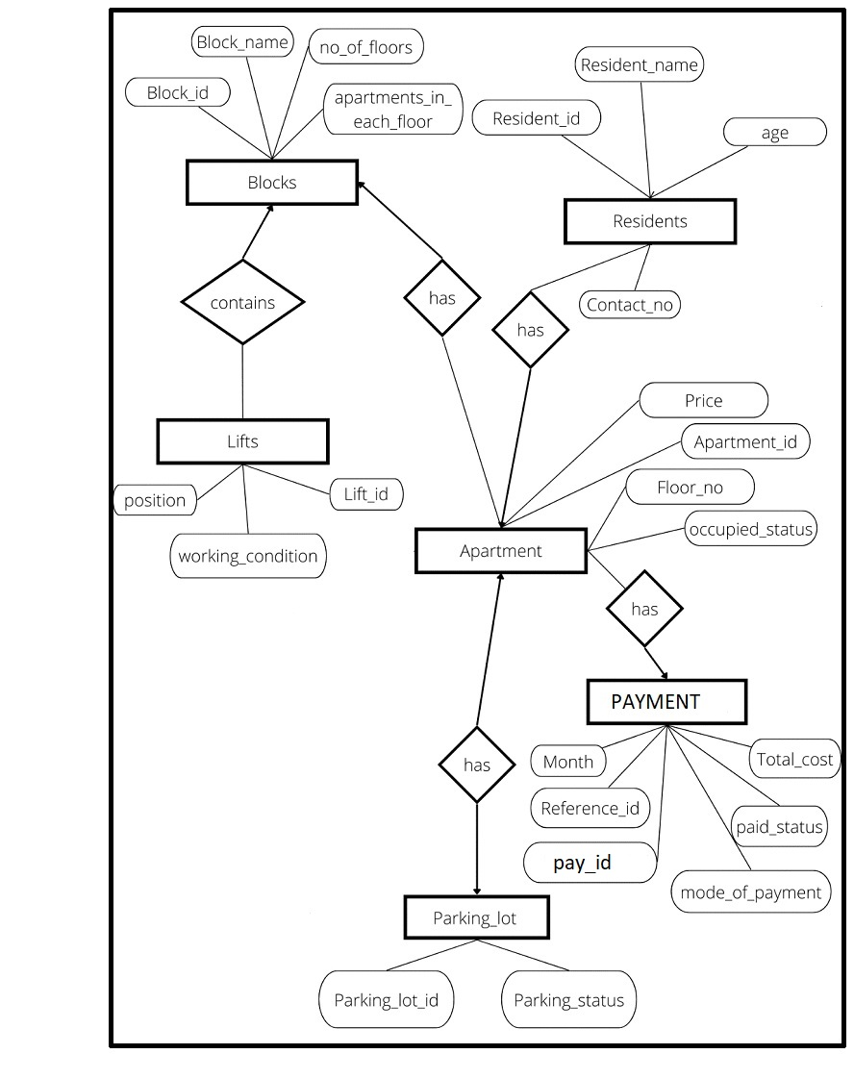

# TABLE DESIGN

|  |  |  |
| --- | --- | --- |
| **S.no** | **Table name** | **Attributes** |
| **1** | Block | Block(block_id,block_name,no_of_floors, apartments_each_floor,no_of_lifts) |
| **2** | Apartment | Apartment(Apartment_id, floor_number, price, occupied, owner_id ) |
| **3** | Residents | Residents(Resident_id, name, gender, age, blood_group, contact) |
| **4** | Lifts | Lifts(lift_id, work_condition,position) |
| **5** | Parking_lot | Parking_lot(parking_lot_id,parking_status) |
| **6** | Payment | Payment(payment_id, bill_arrived_date, bill_paid_date, total_cost, mode_of_payment,ref_id,_apartment_id) |
|  |  |  |

**SYSTEM IMPLEMENTATION**

1. **Create Database Comment:**

i. create database Apartment_Management;

1. **Create Table Comments**

## Blocks

create table Blocks(Block_id int auto_increment primary key,block_name varchar(20),no_of_floors int not null,no_of_apartments_in_each_floor int not null,no_of_lifts int not null);

## Apartment

create table Apartment(Apartment_id int auto_increment primary key,floor_number int not null,price double not null,Block_id int not null,foreign key(Block_id) references Blocks(Block_id));

## Residents

create table Residents(Resident_id int auto_increment primary key,name varchar(50) not null,age int not null,Apartment_id int not null,foreign key(Apartment_id) references Apartment(Apartment_id));

### III. Check constraint for Apartment

alter table Apartment add foreign key(owner_id) references

Residents(Resident_id);

## occupied

create table occupied(Apartment_id int not null primary key,owner_id

int,status boolean,foreign key(Apartment_id) references Apartment( Apartment_id),foreign key(owner_id) references Residents(Resident_id));

### IV. Check constraint for occupied

alter table occupied add check(status = true or(status = false and owner_id is null));

## lifts

create table lifts(lift_id int auto_increment primary

key,working_condition boolean,position varchar(7),Block_id int not null, foreign key(Block_id) references Blocks(Block_id));

## Parking_lot

create table Parking_lot(parking_lot_id int auto_increment primary key, parking_status boolean,Apartment_id int not null,foreign key

(Apartment_id) references Apartment(Apartment_id));

## payment

create table payment(pay_id int auto_increment primary key, bill_arrived_date date not null,bill_paid_date date,total_cost double,mode_of_payment varchar(10),ref_id int,Apartment_id int not null,foreign key(Apartment_id) references Apartment(Apartment_id));

### V. Check constraint for Subscription_log

alter table Subscription_log add check(ref_id is not null or(ref_id is null and mode_of_payment="online"));

Contact create table Contact(Resident_id int not null,contact_number varchar(12),primary key(Resident_id,contact_number),foreign key(Resident_id) references Residents(Resident_id));

## **Sample for Insertion Commands**

a. Blocks Table

insert into Blocks values(1,'A',3,4,2),(2,'B',3,4,3);

### b. Apartment Table

insert into Apartment(Apartment_id,floor_number,price,Block_id) values(101,0,3500000,1),(102,0,3500000,1),(103,0,3500000,1),(10 4,0,3500000,1);

#### c. Residents Table

insert into Residents

values(1,'Vijay','M',30,'O+ve',101),(2,'Shalini','F',29,'B+ve',101);

**Setting owner id for an apartment**

update Apartment set owner_id=1 where Apartment_id=101;

## **Join Command to use find the owner name of the Apartment**

select name from Residents inner join Apartment on Apartment.owner_id=Residents.Resident_id;

lifts insert into lifts values(1,1,'front',1),(2,1,'back',1);

Parking_lot insert into Parking_lot values(1,1,101),(2,1,113);

Contact insert into Contact

values(1,'9095014010'),(2,'9002210555'),(3,'9940891672'),(4,'888 0596912'),(4,'9990011357');

occupied insert into occupied values(101,1,1),(113,4,1); Subsciption_log insert into Subscription_log values(1,'2022-05-01','2022-05-

05',10000,'online',10421,101),(2,'2022-05-03','2022-05-

06',20000,'online',10422,113);

**Source Code for JDBC Connectivity and Menu Driven Program**

**ADMIN LOGIN-PAGE:**

from tkinter import *

from tkinter import messagebox

from PIL import ImageTk

def login():

if unEntry.get() == '' or pwEntry.get() == '':

messagebox.showerror('Error','Fields cannot be empty')

elif unEntry.get()=='admin' and pwEntry.get()=='admin':

messagebox.showinfo('Success','Welcome')

window.destroy()

import admin_page

else:

messagebox.showerror('Error','Please enter correct credentials')

window=Tk()

window.geometry('1525x760+0+0')

window.title('Admin Login System of Apartment Management System')

window.resizable(0,0)

backImage=ImageTk.PhotoImage(file='lpg.webp')

label1=Label(window,image=backImage)

label1.pack()

loginFrame=Frame(window,bg='white')

loginFrame.place(x=400,y=150)

logoImage=PhotoImage(file='alogo.png')

label2=Label(loginFrame,image=logoImage)

label2.grid(row=0,column=1,columnspan=2,pady=10)

unImage=PhotoImage(file='user.png')

unLabel=Label(loginFrame,image=unImage,text='Adminname',compound=LEFT,font=('times new roman',20,'bold'),bg='white')

unLabel.grid(row=1,column=1,pady=10,padx=20)

unEntry=Entry(loginFrame,font=('times new roman',20,'bold'),bd=5,fg='royalblue')

unEntry.grid(row=1,column=2,pady=10,padx=20)

pwImage = PhotoImage(file='pass.png')

pwLabel = Label(loginFrame, image=pwImage, text='Password', compound=LEFT, font=('times new roman', 20, 'bold'),

bg='white')

pwLabel.grid(row=2, column=1, pady=10, padx=20)

pwEntry = Entry(loginFrame, font=('times new roman', 20, 'bold'), bd=5, fg='royalblue')

pwEntry.grid(row=2, column=2, pady=10, padx=20)

loginButton=Button(loginFrame,text='Login',font=('times new roman', 14, 'bold'),width=15,fg='white'

,bg='cornflowerblue',activebackground='cornflowerblue',activeforeground='white',cursor='hand2'

,command=login)

loginButton.grid(row=3,column=2,pady=10)

window.mainloop()

**ADMIN-PAGE:**

from tkinter import *

import time

import ttkthemes

from tkinter import ttk,messagebox

import mysql.connector

mydb=mysql.connector.connect(

host="localhost",

username="root",

passwd="ram9486",

database="apart"

)

if mydb.is_connected():

print("connection established")

mycursor=mydb.cursor()

def exit():

result=messagebox.askyesno('CONFIRM','DO YOU WANT TO LOG-OUT')

if result:

root.destroy()

import admin_login

else:

pass

def clock():

date=time.strftime('%d/%m/%Y')

currenttime=time.strftime('%H:%M:%S')

datetimeLabel.config(text=f' Date: {date}\nTime: {currenttime}')

datetimeLabel.after(1000,clock)

def addapp():

def add_data():

global mycursor,mydb

if floorEntry.get()=='' or priceEntry.get()=='' or BlockEntry.get()=='':

messagebox.showerror('Error','All fields are required',parent=addwin)

else:

query='insert into apartment(Apartment_id,floor_number,price,block_id) values(%s,%s,%s,%s)'

mycursor.execute(query,(idEntry.get(),floorEntry.get(),priceEntry.get(),BlockEntry.get()))

result=messagebox.askyesno('Confirm','Data added successfully.Do you want to make any change?',parent=addwin)

if result:

idEntry.delete(0,END)

floorEntry.delete(0,END)

priceEntry.delete(0,END)

BlockEntry.delete(0,END)

else:

pass

mydb.commit()

addwin=Toplevel()

addwin.grab_set()

addwin.resizable(False,False)

idLabel=Label(addwin,text='Appartment_id',font=('times new roman',20,'bold'))

idLabel.grid(row=0,column=0,padx=30,pady=15,stick=W)

idEntry=Entry(addwin,font=('times new roman', 20, 'bold'), bd=5, fg='dark orange',width=24)

idEntry.grid(row=0,column=1,pady=15,padx=10)

floorLabel = Label(addwin, text='Floor no', font=('times new roman', 20, 'bold'))

floorLabel.grid(row=2, column=0, padx=30, pady=15,stick=W)

floorEntry = Entry(addwin, font=('times new roman', 20, 'bold'), bd=5, fg='dark orange',width=24)

floorEntry.grid(row=2, column=1, pady=15, padx=10)

priceLabel = Label(addwin, text='Price', font=('times new roman', 20, 'bold'))

priceLabel.grid(row=4, column=0, padx=30, pady=15,stick=W)

priceEntry = Entry(addwin,font=('times new roman', 20, 'bold'), bd=5, fg='dark orange',width=24)

priceEntry.grid(row=4, column=1, pady=15, padx=10)

BlockLabel = Label(addwin, text='Block_id', font=('times new roman', 20, 'bold'))

BlockLabel.grid(row=6, column=0, padx=30, pady=15,stick=W)

BlockEntry = Entry(addwin, font=('times new roman', 20, 'bold'), bd=5, fg='dark orange',width=24)

BlockEntry.grid(row=6, column=1, pady=15, padx=10)

addbutton=ttk.Button(addwin,text='SUBMIT',command=add_data)

addbutton.grid(row=7,columnspan=2,pady=15)

def addres():

def add_rdata():

global mycursor,mydb

apid = apidEntry.get()

query=f"select Apartment_id from apartment where Apartment_id='{apid}'"

mycursor.execute(query)

row = mycursor.fetchone()

if row is None:

messagebox.showerror('Error','Apartment not Avilable ')

addresidwin.destroy()

if ridEntry.get()=='' or nameEntry.get()=='' or apidEntry.get()=='' or ageEntry.get()=='' or phoneEntry.get()=='':

messagebox.showerror('Error','All fields are required',parent=addresidwin)

try:

query='insert into residents(Resident_id,name,Apartment_id,age,phone) values(%s,%s,%s,%s,%s)'

mycursor.execute(query,(ridEntry.get(),nameEntry.get(),apidEntry.get(),ageEntry.get(),phoneEntry.get()))

result=messagebox.askyesno('Confirm','Data added successfully.Do you want to make any change?',parent=addresidwin)

if result:

ridEntry.delete(0,END)

nameEntry.delete(0,END)

ageEntry.delete(0,END)

apidEntry.delete(0,END)

phoneEntry.delete(0,END)

else:

pass

mydb.commit()

except:

messagebox.showerror('Error','Id cannot be repeted',parent=addresidwin)

return

query='select * from residents'

mycursor.execute(query)

fetched_data=mycursor.fetchall()

resTable.delete(*resTable.get_children())

for data in fetched_data:

datalist=list(data)

resTable.insert('',END,values=datalist)

addresidwin=Toplevel()

addresidwin.grab_set()

addresidwin.resizable(False,False)

ridLabel=Label(addresidwin,text='Resident_id',font=('times new roman',20,'bold'))

ridLabel.grid(row=0,column=0,padx=30,pady=15,stick=W)

ridEntry=Entry(addresidwin,font=('times new roman', 20, 'bold'), bd=5, fg='dark orange',width=24)

ridEntry.grid(row=0,column=1,pady=15,padx=10)

nameLabel = Label(addresidwin, text='Name', font=('times new roman', 20, 'bold'))

nameLabel.grid(row=2, column=0, padx=30, pady=15,stick=W)

nameEntry = Entry(addresidwin, font=('times new roman', 20, 'bold'), bd=5, fg='dark orange',width=24)

nameEntry.grid(row=2, column=1, pady=15, padx=10)

ageLabel = Label(addresidwin, text='Age', font=('times new roman', 20, 'bold'))

ageLabel.grid(row=4, column=0, padx=30, pady=15,stick=W)

ageEntry = Entry(addresidwin,font=('times new roman', 20, 'bold'), bd=5, fg='dark orange',width=24)

ageEntry.grid(row=4, column=1, pady=15, padx=10)

phoneLabel = Label(addresidwin, text='Phone_no', font=('times new roman', 20, 'bold'))

phoneLabel.grid(row=6, column=0, padx=30, pady=15,stick=W)

phoneEntry = Entry(addresidwin, font=('times new roman', 20, 'bold'), bd=5, fg='dark orange',width=24)

phoneEntry.grid(row=6, column=1, pady=15, padx=10)

apidLabel = Label(addresidwin, text='Apartment_id', font=('times new roman', 20, 'bold'))

apidLabel.grid(row=8, column=0, padx=30, pady=15, stick=W)

apidEntry = Entry(addresidwin, font=('times new roman', 20, 'bold'), bd=5, fg='dark orange', width=24)

apidEntry.grid(row=8, column=1, pady=15, padx=10)

addbutton=ttk.Button(addresidwin,text='SUBMIT',command=add_rdata)

addbutton.grid(row=9,columnspan=2,pady=15)

def editpay():

def submit():

apartment_id = apartment_id_entry.get()

a_id = int(apartment_id)

a_date = a_date_entry.get()

cost = total_cost_entry.get()

query = 'INSERT INTO payment (bill_arrived_date, total_cost, Apartment_id) VALUES (%s, %s, %s)'

values = (a_date, cost, a_id)

try:

mycursor.execute(query, values)

mydb.commit()

messagebox.showinfo("Success", "Subscription added successfully")

except mysql.connector.Error as e:

messagebox.showerror("Error", str(e))

finally:

if mycursor:

mycursor.close()

edpaywin = Toplevel()

edpaywin.grab_set()

edpaywin.resizable(False, False)

apartment_id_label = Label(edpaywin, text="Enter the apartment id:",font=('times new roman',20,'bold'))

apartment_id_label.grid(row=0,column=0,padx=30,pady=15,stick=W)

apartment_id_entry = Entry(edpaywin,font=('times new roman', 20, 'bold'), bd=5, fg='dark orange',width=24)

apartment_id_entry.grid(row=0,column=1,pady=15,padx=10)

a_date_label = Label(edpaywin, text="Enter the Bill Arrived Date:",font=('times new roman',20,'bold'))

a_date_label.grid(row=2,column=0,padx=30,pady=15,stick=W)

a_date_entry = Entry(edpaywin,font=('times new roman', 20, 'bold'), bd=5, fg='dark orange',width=24)

a_date_entry.grid(row=2,column=1,pady=15,padx=10)

total_cost_label = Label(edpaywin, text="Enter the total cost:",font=('times new roman',20,'bold'))

total_cost_label.grid(row=4,column=0,padx=30,pady=15,stick=W)

total_cost_entry = Entry(edpaywin,font=('times new roman', 20, 'bold'), bd=5, fg='dark orange',width=24)

total_cost_entry.grid(row=4,column=1,pady=15,padx=10)

submit_button=ttk.Button(edpaywin,text="Submit",command=submit)

submit_button.grid(row=6,columnspan=2,pady=15)

def parking():

global mycursor, mydb

def topparkin():

pkwin = Toplevel()

pkwin.title('Parking')

pkwin.grab_set()

pkwin.resizable(False, False)

scrollbarx = Scrollbar(pkwin, orient=HORIZONTAL)

scrollbary = Scrollbar(pkwin, orient=VERTICAL)

parktreeTable = ttk.Treeview(pkwin, columns=('Parking_lot_id', 'Parking_status','Apartment_id'),

xscrollcommand=scrollbarx.set, yscrollcommand=scrollbary.set)

scrollbarx.config(command=parktreeTable.xview)

scrollbary.config(command=parktreeTable.yview)

scrollbarx.pack(side=BOTTOM, fill=X)

scrollbary.pack(side=RIGHT, fill=Y)

parktreeTable.pack(fill=BOTH, expand=1)

parktreeTable.heading('Parking_lot_id', text='Parking_lot_id')

parktreeTable.heading('Parking_status', text='Parking_status')

parktreeTable.heading('Apartment_id', text='Apartment_id')

parktreeTable.column('Parking_lot_id', width=50, anchor=CENTER)

parktreeTable.column('Apartment_id', width=200, anchor=CENTER)

parktreeTable.column('Parking_status', width=200, anchor=CENTER)

style = ttk.Style()

style.configure('Treeview', rowheight=40, font=('arial', 12, 'bold'), foreground='black', background='white'

, fieldbackground='white')

style.configure('Treeview.Heading', font=('arial', 14, 'bold'))

parktreeTable.config(show='headings')

query = 'select * from parking_lot'

mycursor.execute(query)

parktreeTable.delete(*parktreeTable.get_children())

fetchdata = mycursor.fetchall()

for data in fetchdata:

parktreeTable.insert('', END, values=data)

def submit():

query = 'delete from parking_lot where Apartment_id=%s'

apid = apartment_id_entry.get()

mycursor.execute(query, (apid,))

mydb.commit()

choice = parking_status_var.get()

a_id = apartment_id_entry.get()

query = "INSERT INTO parking_lot (parking_status, Apartment_id) VALUES (%s, %s)"

mycursor.execute(query, (choice, a_id))

mydb.commit()

messagebox.showinfo("Success", "Parking entry added successfully.")

topparkin()

parkwin = Toplevel()

parkwin.grab_set()

parkwin.resizable(False, False)

apartment_id_label = Label(parkwin, text="Enter the apartment id:", font=('times new roman', 20, 'bold'))

apartment_id_label.grid(row=0, column=0, padx=30, pady=15, stick=W)

apartment_id_entry = Entry(parkwin, font=('times new roman', 20, 'bold'), bd=5, fg='dark orange', width=24)

apartment_id_entry.grid(row=0, column=1, pady=15, padx=10)

parking_status_label = Label(parkwin, text="Parking Status (1 for available, 0 for occupied):")

parking_status_label.grid(row=2, column=0, padx=30, pady=15, stick=W)

parking_status_var = IntVar()

park_status_radio1 = ttk.Radiobutton(parkwin, text="Yes", variable=parking_status_var , value=1)

park_status_radio1.grid(row=2, column=1, pady=15, padx=2)

park_status_radio2 = ttk.Radiobutton(parkwin, text="No", variable=parking_status_var , value=0)

park_status_radio2.grid(row=2, column=2, pady=15, padx=2)

submit_button = ttk.Button(parkwin, text="Submit", command=submit)

submit_button.grid(row=3, columnspan=2, pady=15)

def searchres():

def search_rdata():

global mycursor, mydb

query='select * from residents where Resident_id=%s or name=%s or Apartment_id=%s or age=%s or phone=%s '

mycursor.execute(query,(ridEntry.get(),nameEntry.get(),apidEntry.get(),ageEntry.get(),phoneEntry.get()))

resTable.delete(*resTable.get_children())

fetchdata=mycursor.fetchall()

for data in fetchdata:

resTable.insert('',END,values=data)

searchwin = Toplevel()

searchwin.title('Search resident')

searchwin.grab_set()

searchwin.resizable(False, False)

ridLabel = Label(searchwin, text='Resident_id', font=('times new roman', 20, 'bold'))

ridLabel.grid(row=0, column=0, padx=30, pady=15, stick=W)

ridEntry = Entry(searchwin, font=('times new roman', 20, 'bold'), bd=5, fg='dark orange', width=24)

ridEntry.grid(row=0, column=1, pady=15, padx=10)

nameLabel = Label(searchwin, text='Name', font=('times new roman', 20, 'bold'))

nameLabel.grid(row=2, column=0, padx=30, pady=15, stick=W)

nameEntry = Entry(searchwin, font=('times new roman', 20, 'bold'), bd=5, fg='dark orange', width=24)

nameEntry.grid(row=2, column=1, pady=15, padx=10)

ageLabel = Label(searchwin, text='Age', font=('times new roman', 20, 'bold'))

ageLabel.grid(row=4, column=0, padx=30, pady=15, stick=W)

ageEntry = Entry(searchwin, font=('times new roman', 20, 'bold'), bd=5, fg='dark orange', width=24)

ageEntry.grid(row=4, column=1, pady=15, padx=10)

phoneLabel = Label(searchwin, text='Phone_no', font=('times new roman', 20, 'bold'))

phoneLabel.grid(row=6, column=0, padx=30, pady=15, stick=W)

phoneEntry = Entry(searchwin, font=('times new roman', 20, 'bold'), bd=5, fg='dark orange', width=24)

phoneEntry.grid(row=6, column=1, pady=15, padx=10)

apidLabel = Label(searchwin, text='Apartment_id', font=('times new roman', 20, 'bold'))

apidLabel.grid(row=8, column=0, padx=30, pady=15, stick=W)

apidEntry = Entry(searchwin, font=('times new roman', 20, 'bold'), bd=5, fg='dark orange', width=24)

apidEntry.grid(row=8, column=1, pady=15, padx=10)

addbutton = ttk.Button(searchwin, text='SEARCH', command=search_rdata)

addbutton.grid(row=9, columnspan=2, pady=15)

def deleteres():

selitem=resTable.selection()[0]

rid=resTable.item(selitem)['values'][0]

query='delete from residents where Resident_id= %s '

seldata=(rid,)

mycursor.execute(query,seldata)

mydb.commit()

messagebox.showinfo('Deleted',f'resident {rid} is deleted ')

query1='select * from residents'

mycursor.execute(query1)

fetchdata=mycursor.fetchall()

resTable.delete(*resTable.get_children())

for data in fetchdata:

resTable.insert('',END,values=data)

def viewall():

query1 = 'select * from residents'

mycursor.execute(query1)

fetchdata = mycursor.fetchall()

resTable.delete(*resTable.get_children())

for data in fetchdata:

resTable.insert('', END, values=data)

def unpaybill():

upiwin = Toplevel()

upiwin.title('Unpayed bills')

upiwin.grab_set()

upiwin.resizable(False, False)

scrollbarx = Scrollbar(upiwin, orient=HORIZONTAL)

scrollbary = Scrollbar(upiwin, orient=VERTICAL)

unpayTable = ttk.Treeview(upiwin, columns=('Pay_id', 'Apartment_id','Arrived_date','Total_cost'),

xscrollcommand=scrollbarx.set, yscrollcommand=scrollbary.set)

scrollbarx.config(command=unpayTable.xview)

scrollbary.config(command=unpayTable.yview)

scrollbarx.pack(side=BOTTOM, fill=X)

scrollbary.pack(side=RIGHT, fill=Y)

unpayTable.pack(fill=BOTH, expand=1)

unpayTable.heading('Pay_id', text='Pay_id')

unpayTable.heading('Apartment_id', text='Apartment_id')

unpayTable.heading('Arrived_date', text='Arrived_date')

unpayTable.heading('Total_cost', text='Total_cost')

unpayTable.column('Pay_id', width=50, anchor=CENTER)

unpayTable.column('Apartment_id', width=200, anchor=CENTER)

unpayTable.column('Arrived_date', width=200, anchor=CENTER)

unpayTable.column('Total_cost', width=100, anchor=CENTER)

style = ttk.Style()

style.configure('Treeview', rowheight=40, font=('arial', 12, 'bold'), foreground='black', background='white'

, fieldbackground='white')

style.configure('Treeview.Heading', font=('arial', 14, 'bold'))

unpayTable.config(show='headings')

query = 'select pay_id,Apartment_id,bill_arrived_date,total_cost from payment where bill_paid_date is null and pay_id is not null'

mycursor.execute(query)

unpayTable.delete(*unpayTable.get_children())

fetchdata = mycursor.fetchall()

for data in fetchdata:

unpayTable.insert('', END, values=data)

count=0

text=''

def slider():

global text,count

if count==len(a):

count=0

text=''

text=text+a[count]

sliderLabel.config(text=text)

count+=1

sliderLabel.after(300,slider)

root=ttkthemes.ThemedTk()

root.get_themes()

root.set_theme('radiance')

root.geometry('1474x750+0+0')

root.resizable(0,0)

root.title('Apartment Management System')

datetimeLabel=Label(root,font=('times new roman',18,'bold'))

datetimeLabel.place(x=5,y=5)

clock()

a='Apartment Management System'

sliderLabel=Label(root,text=a,font=('arial',28,'italic bold'),width=50)

sliderLabel.place(x=200,y=0)

slider()

connectButton=ttk.Button(root,text='LOG OUT',command=exit)

connectButton.place(x=1300,y=0)

leftFrame=Frame(root)

leftFrame.place(x=50,y=80,width=300,height=600)

logoimage=PhotoImage(file='resident.png')

logoLabel=Label(leftFrame,image=logoimage)

logoLabel.grid(row=0,column=0)

addflatbutton=ttk.Button(leftFrame,text='Add Appartment',cursor='hand2',width=20,command=addapp)

addflatbutton.grid(row=1,column=0,pady=10)

adresibutton=ttk.Button(leftFrame,text='Add new resident',cursor='hand2',width=20,command=addres)

adresibutton.grid(row=2,column=0,pady=10)

adpaybutton=ttk.Button(leftFrame,text='Add Pay cost',cursor='hand2',width=20,command=editpay)

adpaybutton.grid(row=3,column=0,pady=10)

parkbutton=ttk.Button(leftFrame,text='Edit Parking',cursor='hand2',width=20,command=parking)

parkbutton.grid(row=4,column=0,pady=10)

vunpaybutton=ttk.Button(leftFrame,text='View Unpaid bills',cursor='hand2',width=20,command=unpaybill)

vunpaybutton.grid(row=5,column=0,pady=10)

vallresbutton=ttk.Button(leftFrame,text='View All Residents',cursor='hand2',width=20,command=viewall)

vallresbutton.grid(row=6,column=0,pady=10)

searchbutton=ttk.Button(leftFrame,text='Search Resident',cursor='hand2',width=20,command=searchres)

searchbutton.grid(row=7,column=0,pady=10)

deleresbutton=ttk.Button(leftFrame,text='Delete Resident',cursor='hand2',width=20,command=deleteres)

deleresbutton.grid(row=8,column=0,pady=10)

rightFrame = Frame(root, bg='white')

rightFrame.place(x=350, y=80, width=1100, height=650)

scrollbarx = Scrollbar(rightFrame,orient=HORIZONTAL)

scrollbary = Scrollbar(rightFrame,orient=VERTICAL)

resTable=ttk.Treeview(rightFrame,columns=('Resident_id','Name','Apartment_id','Age','Contact.no'),

xscrollcommand=scrollbarx.set,yscrollcommand=scrollbary.set)

scrollbarx.config(command=resTable.xview)

scrollbary.config(command=resTable.yview)

scrollbarx.pack(side=BOTTOM,fill=X)

scrollbary.pack(side=RIGHT,fill=Y)

resTable.pack(fill=BOTH,expand=1)

resTable.heading('Resident_id',text='Resident_id')

resTable.heading('Name',text='Name')

resTable.heading('Apartment_id',text='Apartment_id')

resTable.heading('Age',text='Age')

resTable.heading('Contact.no',text='Contact.no')

resTable.column('Resident_id',width=50,anchor=CENTER)

resTable.column('Name',width=300,anchor=CENTER)

resTable.column('Apartment_id',width=200,anchor=CENTER)

resTable.column('Age',width=100,anchor=CENTER)

resTable.column('Contact.no',width=200,anchor=CENTER)

style=ttk.Style()

style.configure('Treeview',rowheight=40,font=('arial',12,'bold'),foreground='black',background='white'

,fieldbackground='white')

style.configure('Treeview.Heading',font=('arial',14,'bold'))

resTable.config(show='headings')

root.mainloop()

**USER LOGIN-PAGE:**

from tkinter import *

from tkinter import messagebox

from PIL import ImageTk

import mysql.connector

mydb=mysql.connector.connect(

host="localhost",

username="root",

passwd="ram9486",

database="apart"

)

if mydb.is_connected():

print("login connection established")

mycursor=mydb.cursor()

def login():

username = unEntry.get()

password = pwEntry.get()

query = f"SELECT * FROM residents WHERE name = '{username}' AND resident_id = '{password}'"

mycursor.execute(query)

row = mycursor.fetchone()

if row is not None:

messagebox.showinfo("Login", "Login successful!")

window.destroy()

import profile_page

def uss():

return (username)

def pss():

return (password)

uss(username)

pss(password)

else:

messagebox.showerror("Login", "Invalid username or password.")

window=Tk()

window.geometry('1525x760+0+0')

window.title('Login System of Apartment Management System')

window.resizable(0,0)

backImage=ImageTk.PhotoImage(file='lpg.webp')

label1=Label(window,image=backImage)

label1.pack()

loginFrame=Frame(window,bg='white')

loginFrame.place(x=400,y=150)

logoImage=PhotoImage(file='alogo.png')

label2=Label(loginFrame,image=logoImage)

label2.grid(row=0,column=1,columnspan=2,pady=10)

unImage=PhotoImage(file='user.png')

unLabel=Label(loginFrame,image=unImage,text='Username',compound=LEFT,font=('times new roman',20,'bold'),bg='white')

unLabel.grid(row=1,column=1,pady=10,padx=20)

unEntry=Entry(loginFrame,font=('times new roman',20,'bold'),bd=5,fg='royalblue')

unEntry.grid(row=1,column=2,pady=10,padx=20)

pwImage = PhotoImage(file='pass.png')

pwLabel = Label(loginFrame, image=pwImage, text='Password', compound=LEFT, font=('times new roman', 20, 'bold'),

bg='white')

pwLabel.grid(row=2, column=1, pady=10, padx=20)

pwEntry = Entry(loginFrame, font=('times new roman', 20, 'bold'), bd=5, fg='royalblue')

pwEntry.grid(row=2, column=2, pady=10, padx=20)

loginButton=Button(loginFrame,text='Login',font=('times new roman', 14, 'bold'),width=15,fg='white'

,bg='cornflowerblue',activebackground='cornflowerblue',activeforeground='white',cursor='hand2'

,command=login)

loginButton.grid(row=3,column=2,pady=10)

window.mainloop()

**USER PROFILE:**

from tkinter import *

import time

import ttkthemes

from tkinter import ttk, messagebox

import mysql.connector

mydb = mysql.connector.connect(

host="localhost",

username="root",

passwd="ram9486",

database="apart"

)

if mydb.is_connected():

print("connection established")

mycursor = mydb.cursor()

# functions

def profile():

rightFrame = Frame(root, bg='white')

rightFrame.place(x=350, y=80, width=1200, height=1000)

query = "SELECT * FROM residents WHERE resident_id = %s"

myda=(res_id,)

mycursor.execute(query,myda)

data = mycursor.fetchone()

namelabel = Label(rightFrame, text="Name : " + data[1], font=('arial', 18), bg='white')

namelabel.place(x=200, y=50)

idlabel = Label(rightFrame, text="Resident id : " + str(data[0]), font=('arial', 18), bg='white')

idlabel.place(x=200, y=100)

agelabel = Label(rightFrame, text="Age : " + str(data[3]), font=('arial', 18), bg='white')

agelabel.place(x=200, y=150)

apalabel = Label(rightFrame, text="Apartment id : " + str(data[2]), font=('arial', 18), bg='white')

apalabel.place(x=200, y=200)

pholabel = Label(rightFrame, text="Phone : " + str(data[4]), font=('arial', 18), bg='white')

pholabel.place(x=200, y=250)

def pay():

def setpay():

query="update payment set bill_paid_date=current_date where Apartment_id=%s"

mycursor.execute(query,(data[5],))

mydb.commit

messagebox.showinfo('Success','Paid successful')

pay()

rightFrame = Frame(root, bg='white')

rightFrame.place(x=350, y=80, width=1200, height=1000)

mycursor.execute("select pay_id,bill_arrived_date,bill_paid_date,total_cost,mode_of_payment,payment.Apartment_id from residents,payment where residents.Apartment_id=payment.Apartment_id and Resident_id= %s",

(res_id,))

data = mycursor.fetchone()

if len(data) == 0:

messagebox.showinfo("No Bills", "Sorry!! You don't have any bills arrived yet!")

return

totlabel = Label(rightFrame, text="Bill id : " + str(data[0]), font=('arial', 18), bg='white')

totlabel.place(x=200, y=100)

pidlabel = Label(rightFrame, text="Bill Arrive Date : " + str(data[1]), font=('arial', 18), bg='white')

pidlabel.place(x=200, y=150)

aparlabel = Label(rightFrame, text="Bill Paid Date : " + str(data[2]), font=('arial', 18), bg='white')

aparlabel.place(x=200, y=200)

tcostlabel = Label(rightFrame, text="Total Cost : " + str(data[3]), font=('arial', 18), bg='white')

tcostlabel.place(x=200, y=250)

modelabel = Label(rightFrame, text="Payment Mode : " + str(data[4]), font=('arial', 18), bg='white')

modelabel.place(x=200, y=300)

aplabel = Label(rightFrame, text="Apartment_Id : " + str(data[5]), font=('arial', 18), bg='white')

aplabel.place(x=200, y=350)

if(data[2] is None):

paycost_button = ttk.Button(rightFrame, text="PAY", command=setpay)

paycost_button.place(x=300,y=500)

def park():

rightFrame = Frame(root, bg='white')

rightFrame.place(x=350, y=80, width=1200, height=1000)

query='select * from parking_lot where Apartment_id in(select parking_lot.Apartment_id from residents inner join parking_lot on residents.Apartment_id=parking_lot.Apartment_id and Resident_id=%s)'

mycursor.execute(query,(res_id,))

data=mycursor.fetchone()

if len(data) == 0:

messagebox.showinfo("No Lifts", "Sorry!! Lifts not available!")

return

if data[1]==1:

co='Vehicle Parked'

else:

co='Vehicle Not Parked'

pidlabel = Label(rightFrame, text="Working Condition : " +co, font=('arial', 18), bg='white')

pidlabel.place(x=200, y=150)

aparlabel = Label(rightFrame, text="Parking Id : " + str(data[0]), font=('arial', 18), bg='white')

aparlabel.place(x=200, y=200)

tcostlabel = Label(rightFrame, text="Apartment id : " + str(data[2]), font=('arial', 18), bg='white')

tcostlabel.place(x=200, y=250)

def lift():

rightFrame = Frame(root, bg='white')

rightFrame.place(x=350, y=80, width=1200, height=1000)

query='select * from lifts where Block_id in(select Block_id from residents inner join apartment on residents.Apartment_id=apartment.Apartment_id and Resident_id=%s)'

mycursor.execute(query,(res_id,))

data = mycursor.fetchone()

if len(data) == 0:

messagebox.showinfo("No Lifts", "Sorry!! Lifts not available!")

return

totlabel = Label(rightFrame, text="Lift id : " + str(data[0]), font=('arial', 18), bg='white')

totlabel.place(x=200, y=100)

if data[1]==1:

b='Good'

else:

b='Under repair'

pidlabel = Label(rightFrame, text="Working Condition : " + b, font=('arial', 18), bg='white')

pidlabel.place(x=200, y=150)

aparlabel = Label(rightFrame, text="Position : " + str(data[2]), font=('arial', 18), bg='white')

aparlabel.place(x=200, y=200)

tcostlabel = Label(rightFrame, text="Block id : " + str(data[3]), font=('arial', 18), bg='white')

tcostlabel.place(x=200, y=250)

def exit():

result = messagebox.askyesno('CONFIRM', 'DO YOU WANT TO LOG-OUT')

if result:

root.destroy()

import login_page

else:

pass

def clock():

date = time.strftime('%d/%m/%Y')

currenttime = time.strftime('%H:%M:%S')

datetimeLabel.config(text=f' Date: {date}\nTime: {currenttime}')

datetimeLabel.after(1000, clock)

def idd():

def submit():

global res_id

res_id = res_id_entry.get()

idwin.destroy()

idwin = Toplevel()

idwin.grab_set()

idwin.resizable(False, False)

res_id_label = Label(idwin, text="Enter the Resident id:", font=('times new roman', 20, 'bold'))

res_id_label.grid(row=0, column=0, padx=30, pady=15, stick=W)

res_id_entry = Entry(idwin, font=('times new roman', 20, 'bold'), bd=5, fg='dark orange', width=24)

res_id_entry.grid(row=0, column=1, pady=15, padx=10)

submit_button = ttk.Button(idwin, text="Submit", command=submit)

submit_button.grid(row=6, columnspan=2, pady=15)

count = 0

text = ''

def slider():

global text, count

if count == len(a):

count = 0

text = ''

text = text + a[count] # a

sliderLabel.config(text=text)

count += 1

sliderLabel.after(300, slider)

# GUI

root = ttkthemes.ThemedTk()

root.get_themes()

root.set_theme('radiance')

root.geometry('1474x750+0+0')

root.resizable(0, 0)

root.title('Apartment Management System')

datetimeLabel = Label(root, font=('times new roman', 18, 'bold'))

datetimeLabel.place(x=5, y=5)

clock()

a = 'Apartment Management System'

sliderLabel = Label(root, text=a, font=('arial', 28, 'italic bold'), width=50)

sliderLabel.place(x=200, y=0)

slider()

connectButton = ttk.Button(root, text='LOG OUT', command=exit)

connectButton.place(x=1300, y=0)

leftFrame = Frame(root)

leftFrame.place(x=50, y=80, width=300, height=600)

logoimage = PhotoImage(file='resident.png')

logoLabel = Label(leftFrame, image=logoimage)

logoLabel.grid(row=0, column=0)

profilebutton = ttk.Button(leftFrame, text='PROFILE', cursor='hand2', width=20,command=profile)

profilebutton.grid(row=1, column=0, pady=20)

paybutton = ttk.Button(leftFrame, text='PAYMENT', cursor='hand2', width=20, command=pay)

paybutton.grid(row=3, column=0, pady=20)

parkbutton = ttk.Button(leftFrame, text='PARKING', cursor='hand2', width=20, command=park)

parkbutton.grid(row=5, column=0, pady=20)

liftbutton = ttk.Button(leftFrame, text='LIFT', cursor='hand2', width=20, command=lift)

liftbutton.grid(row=7, column=0, pady=20)

iddbutton = ttk.Button(leftFrame, text='CONNECT ID', cursor='hand2', width=20, command=idd)

iddbutton.grid(row=8, column=0, pady=20)

rightFrame = Frame(root, bg='white')

rightFrame.place(x=350, y=80, width=1200, height=1000)

tlabel = Label(rightFrame, text="WELCOME TO RESIDENT PAGE", font=('times new roman', 25, 'bold'), bg='white',

fg='dark orange')

tlabel.place(x=300, y=250)

root.mainloop()

# SCREENSHOTS:

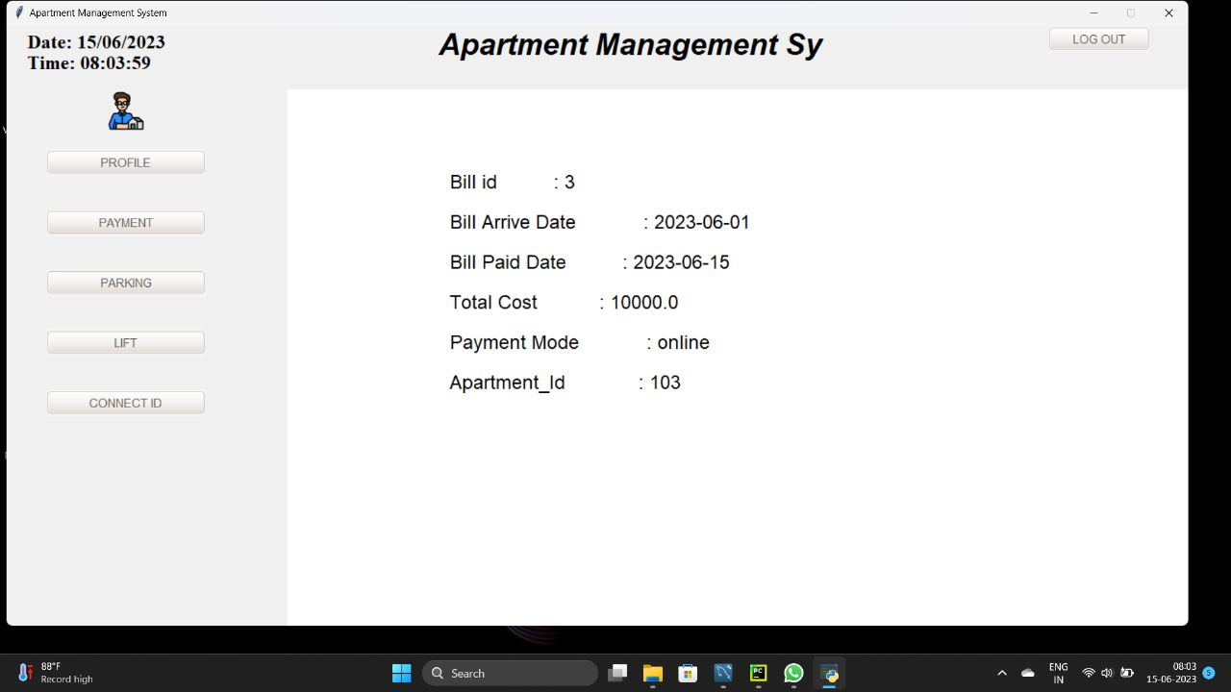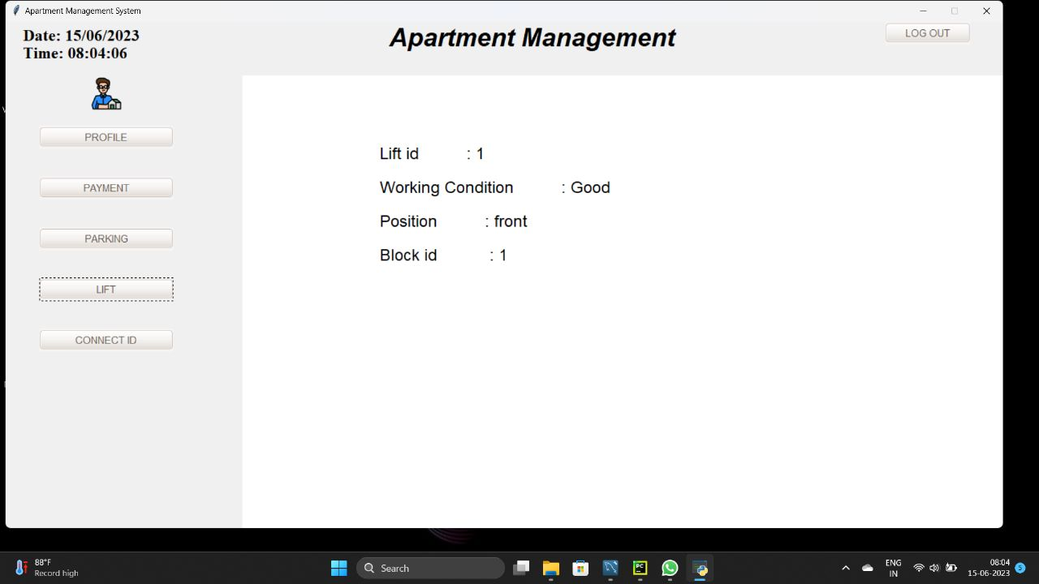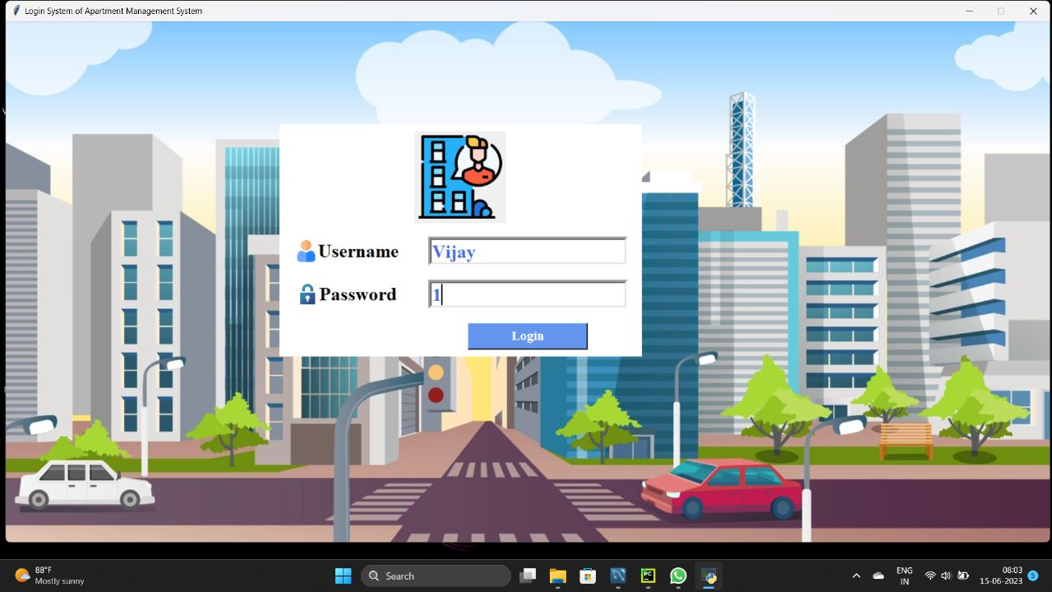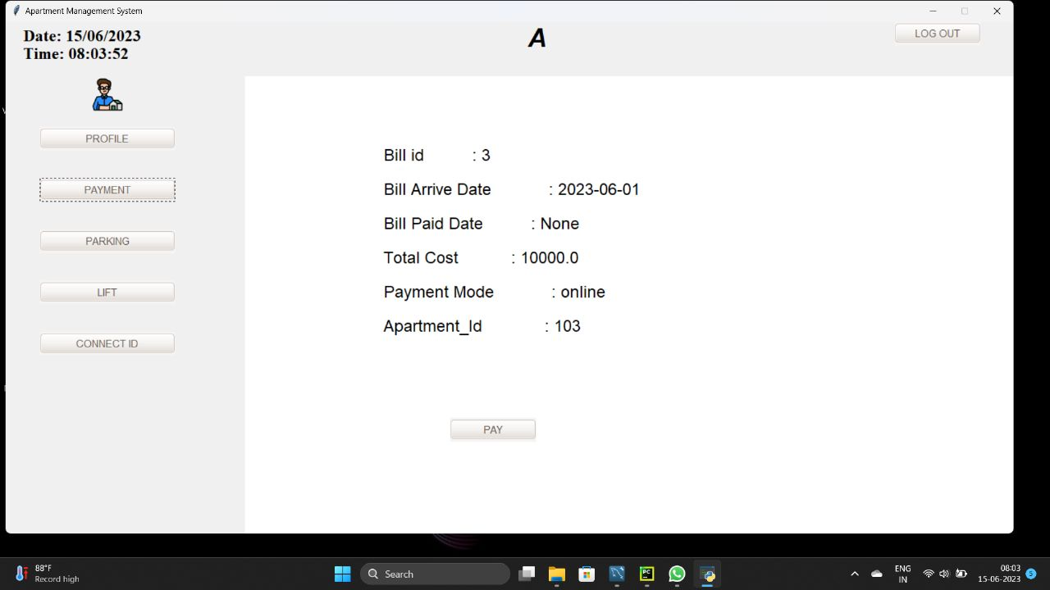

# CONCLUSION:

In our project Apartment Management system, we have stored all the information about the Apartments sold and the residents buying apartments and even status of lifts, maintenance bills payment etc.

This data base is helpful for the applications which facilitate residents to view the visitors log and check the details of maintenance receipts and their status from their place itself. It avoids inconvenience of asking the management team to provide bill details.

We had considered the most important requirements only; many more features and details can be added to our project in order to obtain even more userfriendly applications.

These applications are already in progress and in future they can be upgraded and may become part of amazing technology.

# REFERENCES:

SQL INNER JOIN:

<https://www.mysqltutorial.org/mysql-inner-join.aspx>

SQL SELECT:

<https://www.mysqltutorial.org/mysql-select-statement-query-data.aspx>

SQL UPDATE:

<https://www.mysqltutorial.org/mysql-update-data.aspx>

SQL INSERT:

<https://www.mysqltutorial.org/mysql-insert-statement.aspx>